Sports ground and traffic connection
Charles University Sport Centre Hostivař
Bruslařská 10, Prague 10
METRO A – Skalka station, further BUS NO. 154 or 271 to Gercenova
METRO C - Háje station, further BUS NO. 154 or 271 to Gercenova
GPS N 50°03'07.76"N E 14°32'50.94"
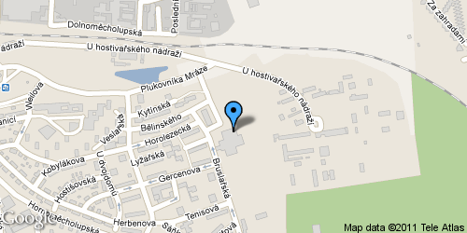
The area of Faculty of Mathematics and Physics, Charles University, Albertov
Albertov, Prague 2
TRAM No. 7, 18, 24 to Albertov
GPS N 50°04'11.04"N E 14°25'35.57"
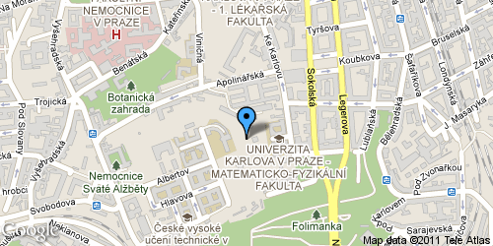
Faculty of Physical Education and Sport- Climbing wall and docks
Prague 7 - Troja
METRO C – Holešovice station, further only one stop by TRAM No.. 14, 17 to Trojská
GPS N 50°06'47.79"N E 14°25'45.53"
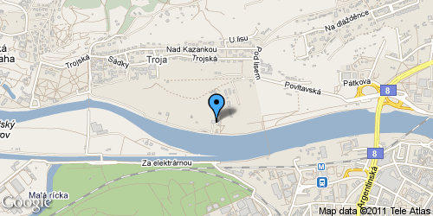
TRAM No. 3, 16, 17, 21 to Podolská vodárna
GPS N 50°03'34.26"N E 14°25'07.38"

"Regata" Docks
Podolské nábřeží 4, Prague 4
TRAM No. 3, 17 to Podolská vodárna

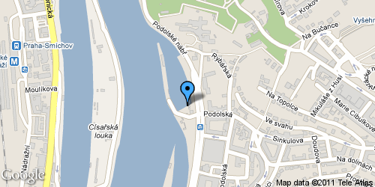
Faculty of Physical Education and Sport- athletic stadium
José Martího 31, Prague 6 - Vokovice
METRO A - Dejvická station, further TRAM No. 20, 26 to Vozovna Vokovice
GPS N 50°05'29.38"N E 14°19'57.89"
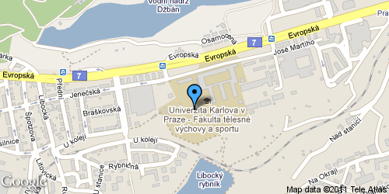
Golf Club Hostivař
Hornoměcholupská 565, Prague 10
METRO A - to Skalka station, further BUS No.154, 271 to Řepčická
METRO C - to Háje station, further BUS No. 154 or 271 to Řepčická
GPS N 50°02'52.13"N E 14°33'05.77"
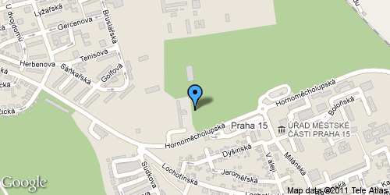

TRAFFIC CONNECTION

Charles University Sport Centre Hostivař
1. METRO A – Skalka station, further BUS No. 154 or271 to Gercenova
2. METRO C – Háje station, further BUS No. 154 or 271 to Gercenova

The area of Faculty of Physics and Mathematics, Charles University Albertov, Prague 2
TRAM No. 7, 18, 24 to Albertov

FTVS UK athletic stadium – José Martího 31, Prague 6 – Vokovice
METRO A – Dejvická station, further TRAM No. 20 or 26 to
Vozovna Vokovice

FTVS UK docks and climbing wall, Prague 7-Troja
METRO C – Holešovice station, then one stop by TRAM No. 5, 14,
17, to Trojská

“Regata“ Docks, Podolské nábřeží 4, Prague 4
TRAM No.. 3, 16, 17, 21, to Podolská vodárna

Golf Club Hostivař, Hornoměcholupská 565, Prague 10
1. METRO A – Skalka station, further BUS No.154 or 271 to Řepčická
2. METRO C – Háje station, further BUS No.. 154 or 271 to Řepčická

WARNING

Those interested in aerobic, aqua aerobic and swimming must have an identity card with them as a deposit for the locker

Participants for other sport events in the Charles University Sport Centre Hostivař must bring a small padlock for the locker.

Rector´s sport day takes place on 16.5.2012.

The text was proof-read by Adam Hamilton, Erasmus student at Faculty of Arts. Thank you.

