Kitasato Global Program for Team-based Healthcare Practice 2026

Mission statement
- To expand the academic international exchange more interdisciplinary, and educate medical professionals with ability to expand their activity worldwide.
- To establish concrete and effective system for global education program across universities, which involves the “team-based healthcare practice”.

Objective:
1. This course lets the students exchange their most recent and evidence based skill and knowledge in health care, as well as sharing social values from an ethical standpoint across countries.
2. The experience of collaborating beyond background and fields let the students learn skills (cultural competency) to overcome the differences and work together as a healthcare team.
3. The students are encouraged to expand their activity in the diverse societal requirements and contribute to
their medical and health care.

Issuance of Credit Certification:
Kitasato University will award a credit for this program. The English syllabus will be available online later, and you can use it for scholarship applications in your home country. Additionally, a credit certificate will be issued once you submit your assignments by the university’s deadline.

Procedure: As part of the team-based healthcare practice, students from different fields (usually 9–10 per group) participate in a case study. Each group will be assigned to a paper patient to discuss the following guiding questions and give a presentation regarding their opinion/ findings.

Guiding Questions (tentative): (1) Set a goal for the assigned patient with certain time period. (2) List the possible healthcare the patient should receive and identify each profession’s role. (3) During the discussion, did any differences arise within the team regarding the case goals or medical/care policies? (4) Using this case study, summarize the team’s thoughts and illustrate considerations or creative approaches in collaborating to provide care to patients and multidisciplinary professionals with diverse medical policies and social, economic, and cultural backgrounds.

Participated Universities: Announcement will be made after confirmed participants.

Participants From Kitasato University: Students from School of Pharmacy, Medicine, Nursing, Allied Health Sciences (Health Science, Medical Laboratory, Clinical Engineering, Radiological Technology, Physical Therapy, Occupational Therapy, Speech Therapy, Orthoptics and Visual Science), and Health Sciences

Program in 2026 : Date: March 9 to March 14 2026
Venue: Kitasato University Sagamihara Campus
1-15-1, Kitazato, Minami-ku, Sagamihara-shi Kanagawa 252-0373, Japan
※The daily program contents are tentative.
Date | Event
March 8 (Sun) | Transfer to the hotel near Kitasato University Sagamihara Campus
March 9 (Mon) | Orientation, icebreaker activity
March 10-13 (Tues-Fri) | Keynote lecture, case study (Discussion), Shirokane Campus (Tokyo) tour, presentation
March 14 (Sat) | Cultural exchange/Sightseeing
March 15 (Sun) | Departure
The schedule for each day will include opportunities for activities with Kitasato students. During the program period, participation in all activities is expected.

Requirements / tasks for the students and prior confirmation
1) Students are required to give a 7-minute presentation about their university, curriculum at the orientation. Please prepare a PowerPoint presentation beforehand.
2) Students from each university are fluent in English conversation and are able to present and discuss the medical/healthcare system in their country.
3) Students will need to do some research before discussing the case study. The Secretariat will send them the scenario as soon as it is ready.
4) Students will be required to complete the questionnaire and submit a reflection paper (1 page essay) after completing the program.
* A certificate of credit requires the submission of assignments by Tuesday, March 17th , 23:59 (Japan Standard Time). If not submitted, the certificate will not be issued under any circumstances.
5) Photos and videos will be taken during the program and will be used for the Kitasato University website and brochures.
6) Students must make their own arrangements for international travel insurance before entering Japan.
7) Have been vaccinated below (1) and (2) required by Kitasato University (if not vaccinated, provide documentation of antibody titers in advance). A history of disease will not be accepted unless it is certified by a medical institution. All documents must be submitted in English.
(1) Proof of vaccination (at least two doses) against measles, rubella, mumps and varicella (chickenpox).
Or an antibody titer certificate that meets the requirement below.
(2) Proof of vaccination against Influenza (Only those vaccinated after September 2025 will be accepted).
*Antibody titer certificate:
When submitting antibody titers, also provide documentation from a university hospital or medical institution certifying that you have acquired immunity.

*Note: This requirement is due to the fact that a student was unable to participate in the program due
to the onset of an infectious disease after arriving in Japan. Thank you for your understanding and cooperation.

8) If dietary considerations are required due to allergies or religious beliefs, these should be noted on the checklist in the application form.
9) Students who wish to request reasonable accommodation during this program are expected to notify using the application form.
10) Participants are responsible for arranging their own air tickets, but must stay at the Kitasato University-designated accommodation from March 8th(check-in) to March 15th(check-out). Participants must also manage their own schedules for the period before and after the program.

Financial support from Kitasato University:
- Partial Subsidy for Air tickets:
The subsidy is calculated based on the distance from Tokyo, assuming participants will depart from the location of their respective universities.
- More than 10,000 km from Tokyo: 120,000 yen/person (e.g., North America)
- Between 8,000 km and 10,000 km from Tokyo: 100,000 yen/person (e.g., North America, Europe and the UK)
- Between 5,000 km and 8,000 km from Tokyo: 60,000 yen/person (e.g., Thailand, Indonesia)
- Between 2,000 km and 5,000 km from Tokyo: 40,000 yen/person (e.g., Taiwan)
- Accommodation: Kitasato University will arrange hotel accommodation from March 8th (check-in) to March 15th (check-out). Due to hotel capacity and the participants balance, room types will be allocated by the university and may not reflect individual preferences.
- A certain amount of expenses for stay

Documents to be submitted for the application *Additional documentation may be required.
1) Application form (ANNEX.1)
2) Copy of student’s passport
3) Copy of Vaccination Certificate / Record OR Antibody Titer Certificate (endorsed by a medical institution)
4) Form for Providing Necessary Information for International Bank Transfer (ANNEX.3)
Application Deadline to Kitasato University: 12th December 2025 [Japan Standard Time]
Please check with your home university for your internal submission deadline.
Contact/Enquiry: Please contact your university designated office

Information about Kitasato University and this program
Kitasato University Introduction Video: https://www.youtube.com/watch?v=FzsTldWw-1M
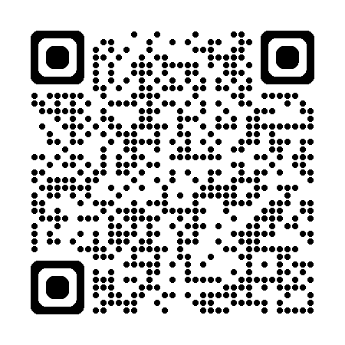Where the program is conducted: https://www.kitasato-u.ac.jp/en/campuses/sagamihara.html
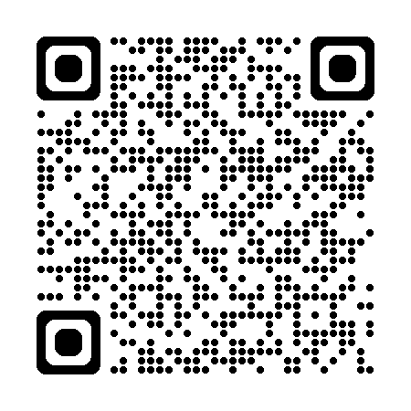Discover the 2025 Program: https://youtu.be/1Z_6Q44-PsY?si=l2UdumaZKTUcgjwm

