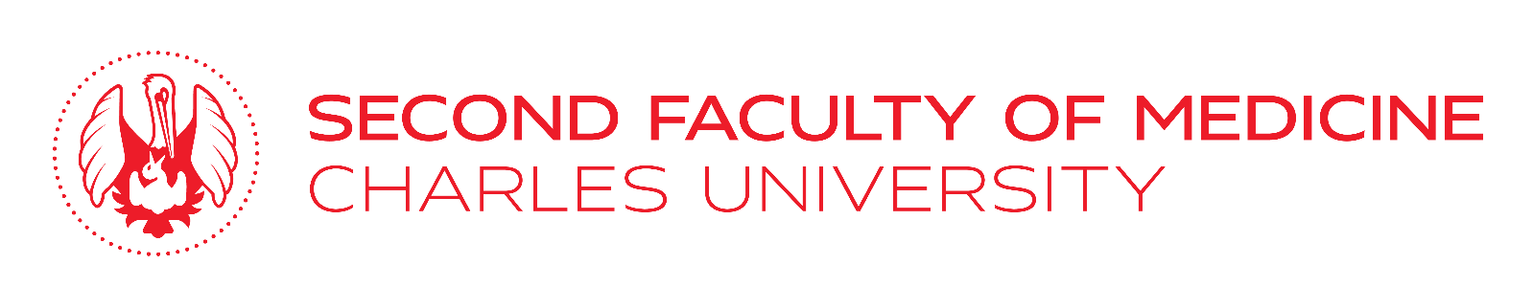
Application for study abroad / practical training
under the Erasmus + programme
in academic year 2021/2022

Please, complete, sign and submit to the Department for Foreign Affairs, Mrs Dana Basařová, email: dana.basarova@lfmotol.cuni.cz no later than 25 April 2021.

Surname:

First name (s):

Date of birth:
Email:
Mobile:
Year of study:
Grade average for all completed academic years of your study:
Repetition of course:
If yes, list exams you had to repeat:
Interruption of study:
If yes, indicate from when to when
Knowledge of languages:
Apart from English
Involvement in student life, internships abroad, etc.
Required universities:
(listed without priority)
1.
Year of your study and dates/term(s) when you are planning to go on Erasmus:
2.
Year of your study and dates/term(s)
when you are planning to go on Erasmus:
3.
Year of your study and dates/term(s)
when you are planning to go on Erasmus:
List of Attachments – as a part of my application I submit:

Language certificate (specify which)

Study plan and / or description of practical training

CV

Documents on Extracurricular activities during my study at Second Faculty of Medicine (please, list here all documents / certificates you are submitting)

Date: | Signature:

