** **

**Study in Prague photo/video competition**

[**http://studyinprague.cz/photocompetition/**](http://studyinprague.cz/photocompetition/)

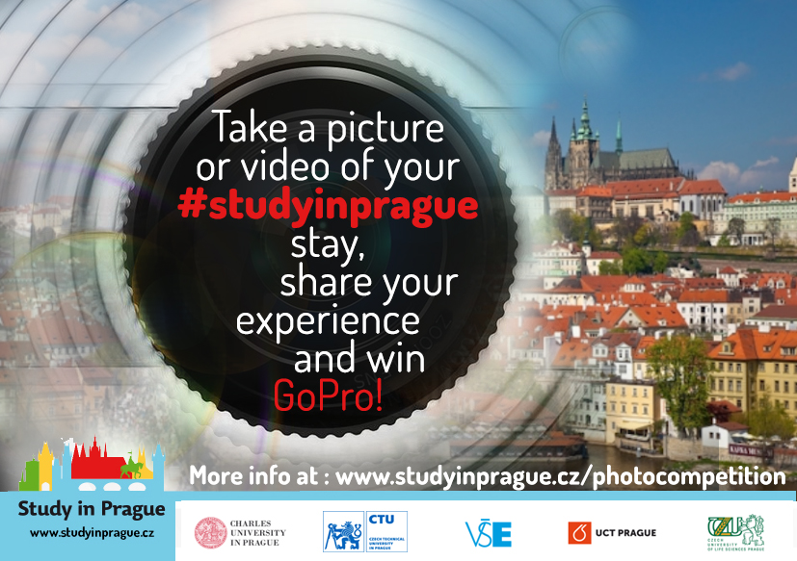

How to submit your photo/video

**3.** Fill out competition **submission form**  completely.

**1.** Post your  
photo/video  
at your personal **Instagram**/ **Facebook**/**Twitter** account.

**2.** Use  
**#studyinprague**  
and  
**#SiPGoPro16** hashtags.

**4.** Wait until  
**5th December** for your name to be announced  
as the winner of the  
competition ;)

General rules:

* theme of the photos/videos: ***Your Prague experience***
* maximum size of the photo is 2MB, maximum length of the video is 90 seconds
* every participant can submit max 3 photos and 1 video
* the photo/video content must not be offensive, present nudity, obscenity or violence nor promote drugs
* **deadline for submitting photos/videos is November 20th 23:59 CET**
* 10 finalists of the photo competition and 5 finalists of the video competition will be chosen by SiP consortium
* author of the best picture and video will be announced on December 5th and awarded with a GoPro camera at a closing ceremony/farewell party at his/her home university

If you have any doubts or questions, contact your Study-in-Prague university coordinator:

**Charles University in Prague**

Czech University of Life Sciences Prague

Czech Technical University in Prague

University of Chemistry and Technology Prague

University of Economics, Prague

#SiPGoPro16 #studyinprague